***Chemistry***

**15: Equilibria of Other Reaction Classes**

**15.3: Multiple Equilibria**

85. Calculate the equilibrium concentration of Ni2+ in a 1.0-*M* solution [Ni(NH3)6](NO3)2.

Solution



Let *x* be the change in concentration as Ni2+ dissociates. Because the initial Ni2+ concentration is 0, the concentration at any times is *x*:



2.0  108(46656*x*7) = 1.0 – *x*

9.33  1012(*x*2) = 1.0 – *x*

Since *x* is small in comparison with 1.0, drop *x*:

9.33  1012(*x*7) = 1.0

*x*7 = 1.07  10–13

*x* = 0.014 *M*

87. Calculate the equilibrium concentration of Cu2+ in a solution initially with 0.050 *M* Cu2+ and 1.00 *M* NH3.

Solution

Assume that all Cu2+ forms the complex whose concentration is 0.050 *M* and the remaining NH3 has a concentration of 1.00 *M* – 4(0.050 *M*) = 0.80 *M*. The complex dissociates:



Let *x* be the change in concentration of Cu2+ that dissociates:

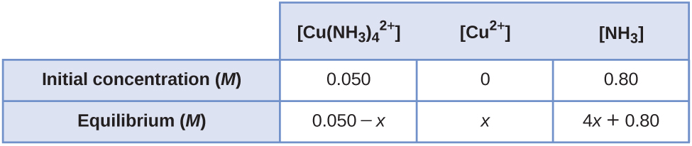



Assume that 4*x* is small when compared with 0.80 and that *x* is small when compared with 0.050:

(0.80)4  1.7  1013 *x* = 0.050

*x* = 7.2  10–15*M*

89. Calculate the Fe3+ equilibrium concentration when 0.0888 mole of K3[Fe(CN)6] is added to a solution with 0.0.00010 *M* CN–.

Solution

Set up a table listing initial and equilibrium concentrations for the reaction:



Let *x* be the concentration of Fe3+ that dissociates when 0.0888 mol dissolves in 1.00 L of 0.00010 *M* CN–. Assume no volume change upon dissolution:

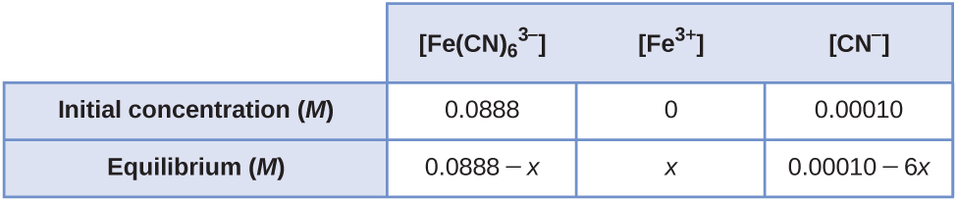



Assume that *x* is small when compared with the terms from which it is subtracted:

0.0888 = (0.00010)6(*x*)(1  1043)



91. The equilibrium constant for the reaction is 1.6 × 1013. Is HgCl2 a strong electrolyte or a weak electrolyte? What are the concentrations of Hg2+ and Cl– in a 0.015-*M* solution of HgCl2?

Solution

Let *x* be the change in the number of moles of Hg2+ that form per liter:

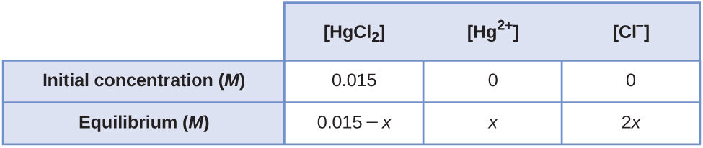



*x*3 = 2.3  10–16

*x* = 6.2  10–6*M* = [Hg2+]

2x = 1.2  10–5*M* = [Cl–]

The substance is a weak electrolyte because very little of the initial 0.015 *M* HgCl2 dissolved.

93. Calculate the molar solubility of Al(OH)3 in a buffer solution with 0.100 *M* NH3 and 0.400 *M*.

Solution





*K*sp = [Al3+][OH–]3 = [Al3+](4.5  10–5)3 = 2  10–32

[Al3+] = 2.2  10–19 (molar solubility)

95. What is the molar solubility of BaSO4 in a 0.250-*M* solution of NaHSO4? *K*a for  = 1.2  10–2.

Solution

Find the amount of  present from *K*a for the equilibrium:



Let *x* be the change in :



Because *K*a is too large to disregard *x* in the expression 0.250 – *x*, we must solve the quadratic equation:

*x*2 + 1.2  10–2*x* – 0.250(1.2  10–2) = 0



*K*sp = [Ba2+] = [Ba2+](0.049) = 2.3  10–8

[Ba2+] = 4.7  10–7 (molar solubility)

97. What is the molar solubility of Pb(OH)2 in a 0.138-*M* solution of CH3NH2?

Solution





Solve the quadratic equation using the quadratic formula:

*x*2 + 4.4  10–4*x* – 0.138(4.4  10–4) = 0



*K*sp = [Pb2+][OH–]2 = [Pb2+](7.6  10–3)2 = 1.2 10–15

[Pb2+] = 2.1  10–11 (molar solubility)

99. A 0.125-*M* solution of Mn(NO3)2 is saturated with H2S ([H2S] = 0.10 *M*). At what pH does MnS begin to precipitate?





Solution

Two equilibria are in competition for the ions and must be considered simultaneously. Precipitation of MnS will occur when the concentration of S2– in conjunction with 0.125 *M* Mn2+ exceeds the *K*sp of MnS. The [S2–] must come from the ionization of H2S as defined by the equilibrium:





As a saturated solution of H2S is 0.10 *M*, this later expression becomes:



From the equilibrium of MnS, the minimum concentration of S2– required to cause precipitation is calculated as:



*K*sp = [Mn2+][S2–] = 2.3  10–13



This amount of S2– will exist in solution at a pH defined by the H2S equilibrium:









101. Calculate the molar solubility of CdCO3 in a buffer solution containing 0.115 *M* Na2CO3 and 0.120 *M* NaHCO3

Solution

Three equilibria are involved:







First, find the pH of the buffer from the Henderson-Hasselbach equation. Then find [H3O+]:



10.252 + log = 10.252 – 0.018 = 10.234

In this case, several more significant figures are carried than justified so that the value of the log ratio is meaningful:



Now, find the concentration of  present in the buffer solution. Next, using  and *K*sp, calculate the concentration of Cd2+. This latter value represents the molar solubility. From  determine [H2CO3]:



[H2CO3] = 1.62  10–5

From , find the concentration of :

 = 0.116 *M*

*K*sp = [Cd2+] = [Cd2+](0.116) = 5.2  10–12



103. Calculate the concentration of Cd2+ resulting from the dissolution of CdCO3 in a solution that is 0.250 *M* in CH3CO2H, 0.375 *M* in NaCH3CO2, and 0.010 *M* in H2CO3.

Solution

For *K*sp, (CdCO3) = [Cd2+] = 5.2  10–12, the amount of  is governed by *K*a of H2CO3, 4.3  10–7, and *K*a of , 5.6  10–11, and  by *K*a of acetic acid. First, calculate the  from *K*a of acetic acid (HOAc):



From this and *K*a for H2CO3, calculate  present. As  is fixed by *K*a of acetic acid:





From  we obtain :



From the solubility product:

*K*sp = [Cd2+] = 5.2  10–12 = Cd2+ (1.67  10–9)



105. Calculate the volume of 1.50 *M* CH3CO2H required to dissolve a precipitate composed of 350 mg each of CaCO3, SrCO3, and BaCO3.

Solution







Total: 7.64  10–3 mol

CaCO3: *K*sp = 8.7  10–9

SrCO3: *K*sp = 7  10–10

BaCO3: *K*sp = 1.6  10–9

Solubilities are approximately equal.

When the three solids dissolve, 7.64  10–3 mol of metal ions and 7.64  10–3 mol of  are initially present. The  reacts with CH3CO2H to form :





This *K* value is large, so virtually all  undergoes this reaction and approximately 7.64  10–3 mol of  forms. The  reacts with CH3CO2H:





This reaction is virtually complete as well (*K* is large).

For each mol of  produced, 2 mol of CH3CO2H is required for conversion to H2CO3. Thus 15.3 × 10–3mol CH3CO2H is needed:



107. What mass of NaCN must be added to 1 L of 0.010 *M* Mg(NO3)2 in order to produce the first trace of Mg(OH)2?

Solution

There are two equilibria involved: The Mg(NO3)2 dissolves, and [Mg2+] = 0.010 *M*.

[Mg2+][OH–]2 = *K*sp = 8.9  10–12

(0.010)[OH–]2 = 8.9  10–12

[OH–] = 2.9  10–5*M*

We need to add enough CN– to make [OH–] = 2.9  10–5*M*. Both OH– and HCN come from CN–, so [OH–] = [HCN]:



[CN–] = 7.6  10–5 *M*

molNaCN = mol HCN + mol CN– = 2.9  10–5 + 7.6  10–5 = 1.1 10–4



109. The following question is taken from a Chemistry Advanced Placement Examinationand is used with the permission of the Educational Testing Service.

Solve the following problem:



In a saturated solution of MgF2 at 18°C, the concentration of Mg2+ is 1.21  10–3*M*. The equilibrium is represented by the equation above.

(a) Write the expression for the solubility-product constant, *K*sp, and calculate its value at 18 °C.

(b) Calculate the equilibrium concentration of Mg2+ in 1.000 L of saturated MgF2 solution at 18 °C to which 0.100 mol of solid KF has been added. The KF dissolves completely. Assume the volume change is negligible.

(c) Predict whether a precipitate of MgF2 will form when 100.0 mL of a 3.00  10–3-*M* solution of Mg(NO3)2 is mixed with 200.0 mL of a 2.00  10–3-*M* solution of NaF at 18°C. Show the calculations to support your prediction.

(d) At 27 °C the concentration of Mg2+ in a saturated solution of MgF2 is 1.17  10–3*M*. Is the dissolving of MgF2 in water an endothermic or an exothermic process? Give an explanation to support your conclusion.

Solution

(a) *K*sp = [Mg2+][F–]2 = (1.21  10–3)(2  1.21  10–3)2 = 7.09  10–9;

(b) *K*sp = [Mg2+][F–]2 = [*x*][0.100 + 2*x*]2 = 7.09  10–9

Assume that 2*x* is small when compared with 0.100 *M*.

0.100*x* = 7.09  10–9

*x* = [MgF2] = 7.09  10–7 *M*

The value 7.09  10–7 *M* is quite small when compared with 0.100 *M*, so the assumption is valid.

(c) Determine the concentration of Mg2+ and F– that will be present in the final volume. Compare the value of the ion product [Mg2+][F–]2 with *K*sp. If this value is larger than *K*sp, precipitation will occur.

0.1000 L  3.00  10–3 *M* Mg(NO3)2 = 0.3000 L  *M* Mg(NO3)2

*M* Mg(NO3)2 = 1.00  10–3*M*

0.2000 L  2.00  10–3*M* NaF = 0.3000 L *M* NaF

*M* NaF = 1.33  10–3*M*

ion product = (1.00  10–3)(1.33  10–3)2 = 1.77  10–9

This value is smaller than *K*sp, so no precipitation will occur.

(d) MgF2 is less soluble at 27 °C than at 18 °C. Because added heat acts like an added reagent, when it appears on the product side, the Le Châtelier’s principle states that the equilibrium will shift to the reactants’ side to counter the stress. Consequently, less reagent will dissolve. This situation is found in our case. Therefore, the reaction is exothermic.

111. Which of the following compounds, when dissolved in a 0.01-*M* solution of HClO4, has a solubility greater than in pure water: AgBr, BaF2, Ca3(PO4)3, ZnS, PbI2? Explain your answer.

Solution

BaF2, Ca3(PO4)2, ZnS; each is a salt of a weak acid, and the from perchloric acid reduces the equilibrium concentration of the anion, thereby increasing the concentration of the cations

113. What is the effect on the amount of CaHPO4 that dissolves and the concentrations of Ca2+ and  when each of the following are added to a mixture of solid CaHPO4 and water at equilibrium?

(a) CaCl2

(b) HCl

(c) KClO4

(d) NaOH

(e) CaHPO4

Solution

Effect on amount of solid CaHPO4, [Ca2+], [OH–]: (a) increase, increase, decrease; (b) decrease, increase, decrease; (c) no effect, no effect, no effect; (d) decrease, increase, decrease; (e) increase, no effect, no effect

115. A volume of 50 mL of 1.8 *M* NH3 is mixed with an equal volume of a solution containing 0.95 g of MgCl2. What mass of NH4Cl must be added to the resulting solution to prevent the precipitation of Mg(OH)2?

Solution

The hydroxide ion concentration in solution depends on two simultaneous equilibria. The maximum allowable [OH–] can be calculated from the *K*sp of Mg(OH)2 based on the [Mg2+]:



[Mg2+] = [MgCl2]



[Mg2+][OH–]2 = 8.9  10–12



[OH–] = 9.4  10–6 *M*

The [OH–] produced from NH3 must be suppressed to 9.4  10–6 *M* by buffering the solution through the addition of NH4Cl. The required  can be calculated from the equilibrium constant expression for ammonia:





At equilibrium, [NH3] approximately equals , since 9.4  10–6 is small with respect to 0.90. Therefore,  is:





mass NH4Cl required = (1.72 mol/L)(53.5 g/mol)(0.10 L) = 9.2 g

This resource file is copyright 2015, Rice University. All Rights Reserved.